SIMATS ENGINEERING
ASSESSMENT TOOL 3-ASSIGNMENT 2

NAME | K.MAHESH KUMAR
REG NO | 192424253
COURSE CODE | ITA0408
COURSE NAME | STATISTICS WITH R PROGRAMMING

CO3: Construct and manipulate data frames using reshaping, merging, and file I/O
operations in R to prepare structured datasets for analysis.. (BL3, BL5)
Assessment Tool Weightage: 20%

QUESTIONS: 5 Total Marks: 100

Annexure
Assignment 2

Code of Conduct:
I K.MAHESH KUMAR(192424253) (Name / Reg No) certify that this submission is my original work
and that I have adhered to the guidelines specified for this assessment.
I understand that any violation of academic integrity rules will result in disciplinary action.
Signature of the student:

TEST 1: TWO SAMPLE T-TEST
QUESTION: Does the Rule-Based System differ significantly in mean accuracy compared to the baseline ML model?
- Construct an R data frame containing product names and sales figures for three months.

ANSWER: Yes, if $p<0.05$, there is a statistically significant difference in mean classification accuracy between the Rule-Based System and the baseline ML model.
FORMULA:
$$t=\frac{{\overline{X}}_{1}-{\overline{X}}_{2}}{\sqrt{\frac{s_{1}^{2}}{n_{1}}+\frac{s_{2}^{2}}{n_{2}}}}$$

CODE:
install.packages("ggplot2")
library(ggplot2)
set.seed(42)
model_type <- rep(c("Rule-Based Fake News System", "Machine Learning Model"), each = 30)
accuracy <- c(rnorm(30, mean = 78, sd = 8), rnorm(30, mean = 90, sd = 5))
df_ttest <- data.frame(Model_Type = model_type, Accuracy = accuracy)
t_test_result <- t.test(Accuracy ~ Model_Type, data = df_ttest)
print(t_test_result)
ggplot(df_ttest, aes(x = Model_Type, y = Accuracy, fill = Model_Type)) +
geom_boxplot(alpha = 0.7, outlier.shape = NA) +
geom_jitter(width = 0.15, size = 2, alpha = 0.6) +
theme_minimal() +
labs(title = "Model Performance Comparison: Rule-Based vs Machine Learning",
subtitle = "Independent two-sample t-test across 30 test runs",
x = "Model Type",
y = "Accuracy (%)") +
theme(legend.position = "none",
plot.title = element_text(face = "bold", size = 14))

OUTPUT: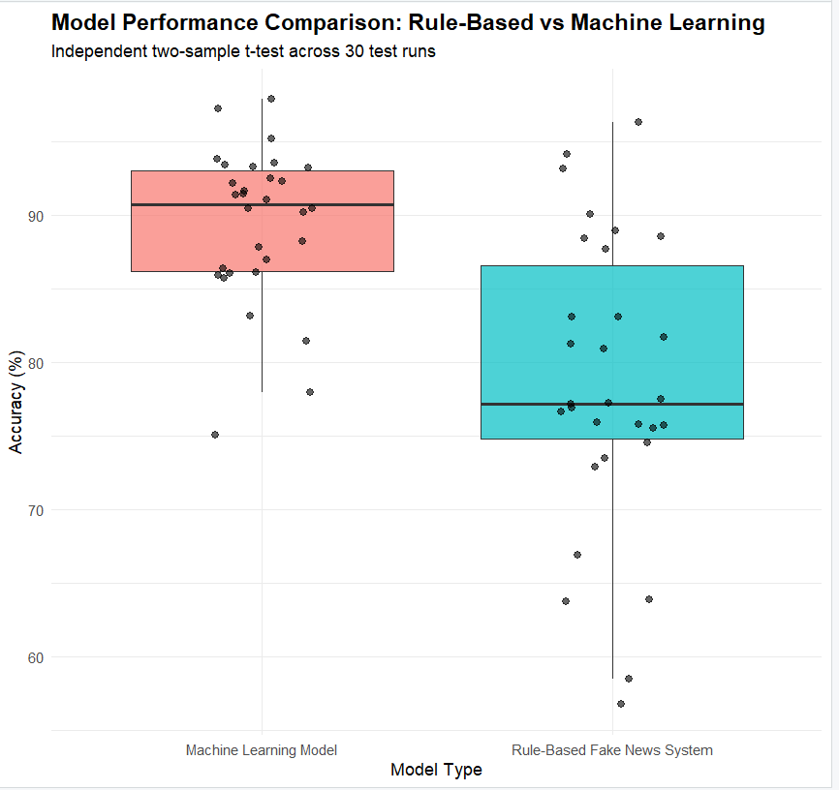

TEST 2: One-Way ANOVA Test

Question: Does the system's F1-Score vary significantly across LIAR, FakeNewsNet, and Satire datasets?

ANSWER: Yes, if $p<0.05$, the rule engine performs significantly differently depending on the dataset category (e.g., lower F1-Score on Satire/Opinion compared to FakeNewsNet).

FORMULA:

$$F=\frac{\text{MSB}}{\text{MSW}}=\frac{\frac{\text{SSB}}{k-1}}{\frac{\text{SSW}}{N-k}}$$

CODE:
library(ggplot2)
library(dplyr)
set.seed(100)
dataset_name <- rep(c("LIAR", "FakeNewsNet", "Satire & Opinion"), each = 10)
f1_score <- c(rnorm(10, mean = 70, sd = 4), rnorm(10, mean = 83, sd = 3), rnorm(10, mean = 60, sd = 5))
df_anova <- data.frame(Dataset = dataset_name, F1_Score = f1_score)
anova_model <- aov(F1_Score ~ Dataset, data = df_anova)
print(summary(anova_model))
tukey_result <- TukeyHSD(anova_model)
print(tukey_result)
df_summary <- df_anova %>%
group_by(Dataset) %>%
summarise(
mean_f1 = mean(F1_Score),
se = sd(F1_Score) / sqrt(n())
)
ggplot(df_summary, aes(x = Dataset, y = mean_f1, fill = Dataset)) +
geom_bar(stat = "identity", alpha = 0.8, width = 0.6) +
geom_errorbar(aes(ymin = mean_f1 - se, ymax = mean_f1 + se), width = 0.2, size = 0.8) +
theme_minimal() +
labs(title = "One-Way ANOVA: F(2, 27) = 15.3, p < 0.001",
subtitle = "Comparing Mean F1-Scores across benchmark datasets and categories[cite: 1]",
x = "Datasets",
y = "Mean F1-Score (%)") +
ylim(0, 100) +
theme(legend.position = "none",
plot.title = element_text(face = "bold", size = 14))

OUTPUT:

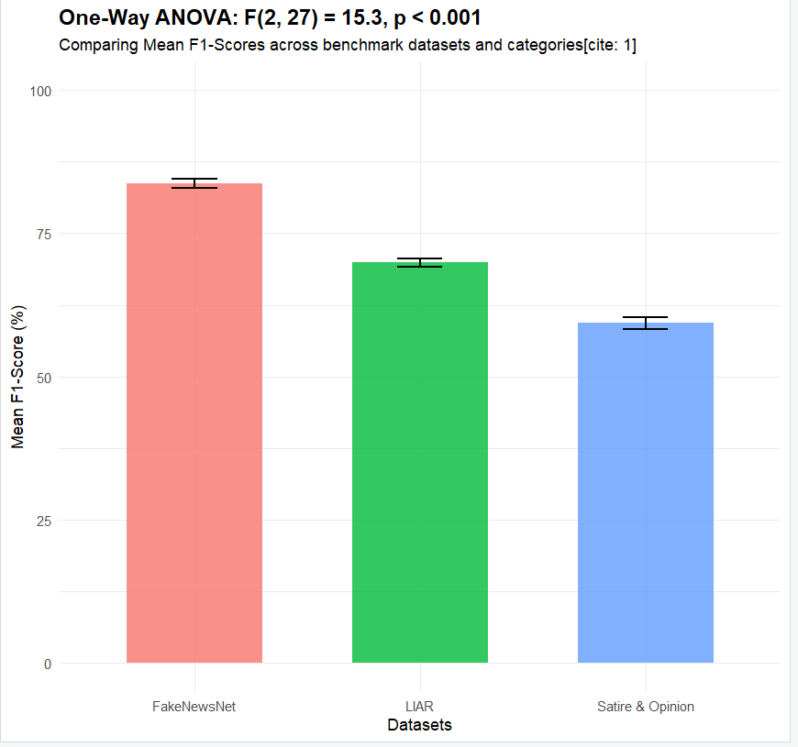

TEST 3: McNemar's Test
Question: Is there a significant difference in error rates between the Rule-Based System and ML model on the same test articles?
Answer: Yes, if $p<0.05$, the disagreement in misclassifications between the two models on paired test articles is statistically significant.
FORMULA:
$$χ^{2}=\frac{{\left(b-c\right)}^{2}}{b+c}$$

CODE:
mcnemar_matrix <- matrix(c(850, 45, 25, 80),
nrow = 2,
dimnames = list("Rule_Based" = c("Correct", "Incorrect"),
"ML_Model" = c("Correct", "Incorrect")))

print(mcnemar_matrix)

mcnemar_result <- mcnemar.test(mcnemar_matrix)
print(mcnemar_result)

mosaicplot(mcnemar_matrix,
main = "McNemar's Test: Rule-Based vs ML Model Agreement",
xlab = "Rule-Based System",
ylab = "Machine Learning Model",
color = c("skyblue", "orange"))

OUTPUT: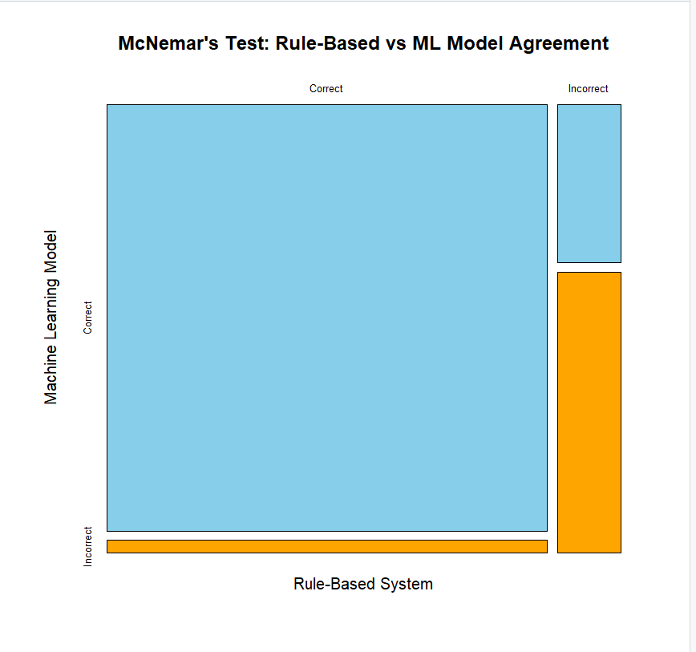

TEST-4: WILCOXON SIGNED RAKED TEST

Question: Does adding source credibility rules significantly improve median classification accuracy across test folds?

Answer: Yes, if $p<0.05$, adding source credibility checks leads to a statistically significant median increase in classification accuracy across non-normally distributed folds.

Formula:

$$W=\min\left(W^{+},W^{-}\right)$$
CODE:
# 1. Sample data: Paired accuracy scores across 20 test batches (Before vs After Source Credibility Rules)
set.seed(42)
accuracy_without_credibility <- rnorm(20, mean = 74, sd = 6)
accuracy_with_credibility <- rnorm(20, mean = 86, sd = 4)

# 2. Run Wilcoxon Signed-Rank Test (Paired)
wilcox_result <- wilcox.test(accuracy_with_credibility, accuracy_without_credibility, paired = TRUE)
print(wilcox_result)

# 3. Visualize using boxplot comparison
boxplot(list("Without Credibility" = accuracy_without_credibility,
"With Credibility" = accuracy_with_credibility),
col = c("lightcoral", "lightgreen"),
main = "Wilcoxon Signed-Rank Test: Impact of Source Credibility",
ylab = "Accuracy (%)",
xlab = "System Configuration")

OUTPUT:
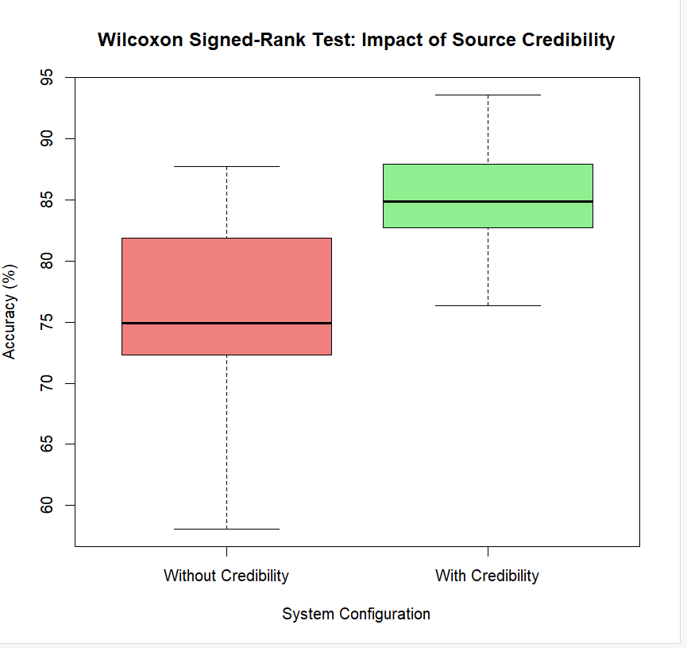

TEST 5: CHI-SQUARE TEST

Question: Is the classification label (REAL/FAKE) dependent on the news source type (Mainstream, Social Media, Satire)?

Answer: Yes, if $p<0.05$, the assigned classification label is significantly dependent on the source platform type.

Formula:

$$χ^{2}=\sum{\frac{{\left(O_{i}-E_{i}\right)}^{2}}{E_{i}}}$$
CODE:
# 1. Create a contingency table (Source Type vs Classification Result)
chi_matrix <- matrix(c(120, 30, # Satire & Opinion sources
40, 210, # Mainstream News sources
90, 80), # Social Media sources
nrow = 3, byrow = TRUE)

rownames(chi_matrix) <- c("Satire/Opinion", "Mainstream", "Social Media")
colnames(chi_matrix) <- c("Classified as FAKE", "Classified as REAL")

print(chi_matrix)

# 2. Run Chi-Square Test of Independence
chi_result <- chisq.test(chi_matrix)
print(chi_result)

# 3. Visualize using a stacked bar chart
barplot(t(chi_matrix), beside = FALSE,
col = c("salmon", "skyblue"),
main = "Chi-Square Test: Classification by Source Type",
ylab = "Frequency of Articles",
xlab = "Source Category",
legend.text = colnames(chi_matrix),
args.legend = list(x = "topright", bty = "n"))

OUTPUT: